**CSC 250 – Program Design Document Program 5**

**John Akujobi**

**Structure Chart**

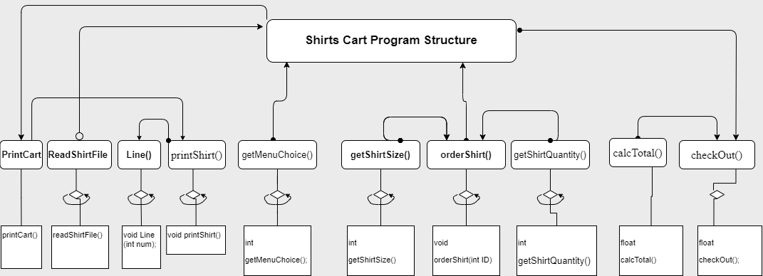

**Functions Design (give the prototype and a short description for each function**

(Note: Many of these functions use the constant structure for the tshirts in their workings)

1. printShirt() - Function to print the shirts in the vendor's menu
   * void printShirt();
   * Prints the shirts in the vendor's menu, including their ID, name, cost, quantity, and total cost.
   * Takes no input and returns nothing.
2. readShirtFile() - Function to read the shirt file and set the values of the shirt structure
   * void readShirtFile();
   * Reads the shirt file and sets the cost, name, id, and quantity of each shirt in the vendor's menu.
   * Takes no input and returns nothing.
3. Line() - Function to print a line of dashes
   * void Line(int num);
   * Prints a line of dashes to the console.
   * Takes an integer num as input, which determines the number of dashes to print, and returns nothing.
4. printCart() - Function to print the cart
   * void printCart();
   * Prints the items in the cart, including their ID, name, cost, quantity, and total cost.
   * Takes no input and returns nothing.

----------------------------------------------------------------------------------------------------

YOUR CART

----------------------------------------------------------------------------------------------------

| ID | Product Name | Cost | Qty | Total || Details ||

| | | $ | | Cost*Qty || S M L XL XXL ||

----------------------------------------------------------------------------------------------------

| 1 | Go Jacks! Long Sleeve | 29.5 | 0 | 0 || 0 0 0 0 0 ||

| 2 | Tangled SD Button Down | 35.99 | 0 | 0 || 0 0 0 0 0 ||

| 3 | Engineer Jack T-shirt | 19.5 | 0 | 0 || 0 0 0 0 0 ||

| 4 | Jacks Rain Jacket | 44.5 | 0 | 0 || 0 0 0 0 0 ||

| 5 | Go Jacks! Fleece | 31.99 | 0 | 0 || 0 0 0 0 0 ||

----------------------------------------------------------------------------------------------------

1. getMenuChoice() - Function to print the menu and get the user's choice
   * int getMenuChoice();
   * Prints the main menu options and gets the user's choice.
   * Takes no input and returns an integer representing the user's choice from the menu.
2. getShirtSize() - Function to get the size of the shirt
   * int getShirtSize();
   * Prints the available shirt sizes and gets the user's choice.
   * Takes no input and returns an integer representing the user's size choice.
3. getShirtQuantity() - Function to get the quantity of the shirt
   * int getShirtQuantity();
   * Gets the quantity of the shirt that the user wants to purchase.
   * Takes no input and returns an integer representing the user's choice.
4. orderShirt() - Function to order a shirt
   * void orderShirt(int ID);
   * Takes the ID of the shirt the user wants to order as input, and gets the size and quantity the user wants to order. It then calculates the total cost of the order and updates the cart.
   * Returns nothing.
5. main() - Main function of the program
   * int main();
   * Initializes variables, reads the shirt file, and prints the cart. Then, it gets the user's menu choice and processes it accordingly.
   * Takes no input and returns an integer.
6. checkOut() - Function to check out and finalize the purchase
   * void checkOut();
   * Prints the cart and the total cost, and asks the user for their payment information. Once the payment is confirmed, it clears the cart and ends the program.
   * Takes no input and returns nothing.
7. calcTotal() - Function to calculate the total cost of the order
   * float CalcTotal();
   * Takes the ID, size, and quantity of the shirt as input, and calculates the total cost of the order.
   * Returns a float representing the total cost of the order.

**Time Estimate**

|  |  |  |
| --- | --- | --- |
| **Function Name** | **Estimated Time in mins** | **Actual Time in mins** |
| Program design | 40 | 35 |
| printShirt() | 15 mins | 10 mins |
| readShirtFile() | 10 mins | 5 mins |
| Line() | 2 mins | 2 mins |
| printCart() | 15 mins | 20 mins |
| getMenuChoice() | 15mins | 12 mins |
| getShirtSize() | 15 mins | 15 mins |
| getShirtQuantity() | 15 mins | 15 mins |
| orderShirt() | 15 mins | 20 mins |
| main() | 20 mins | 12 mins |
| Debugg | 30 mins | 25 mins |
| **Total Time** | **195 mins** | **171 mins** |

Flowchart using Text

+-----------------------+

| main() |

+-----------------------+

|

|

v

+-----------------------+

| readShirtFile () |

+-----------------------+

|

|

v

+-----------------------+

| printShirt () |

+-----------------------+

|

|

v

+-----------------------+

| Line() |

+-----------------------+

|

|

v

+-----------------------+

| printCart() |

+-----------------------+

|

|

v

+-----------------------+

| orderShirt() |

+-----------------------+

|

|

v

+-----------------------+

| getMenuChoice() |

+-----------------------+

|

|

v

+-----------------------+

| getShirtSize() |

+-----------------------+

|

|

v

+-----------------------+

| getShirtQuantity() |

+-----------------------+

|

|

v

+-----------------------+

| CalcTotal() |

+-----------------------+

|

|

v

+-----------------------+

| CheckOut() |

+-----------------------+